NuEVI
user guide



Firmware version 1.2.7
Johan Berglund 2018
Short history

The Electronic Valve Instrument was invented back in the early 1970s by Nyle Steiner. The first production instruments were using mechanical switches in a handset connected to an analog synthesizer module, and they were sold from 1975 to 1979 by the Steiner- Parker company. When the company had dissolved, the instrument was produced by Crumar.

In the mid 80s, Steiner designed and built a number of instruments with a more complex synthesizer and touch sensing for the keys. They were referred to as Steinerphones, and and came in both brass and woodwind variety.

In 1987 a new type of EVI was licensed and sold by AKAI. This new version together with its woodwind counterpart released at the same time, the EWI, was using touch sensing for the finger controls and a programmable synth module capable of sending MIDI for controlling other synthesizers. The Akai EVI was discontinued due to not selling as well as the EWI that is still made by AKAI in new incarnations.

For a while Nyle Steiner did conversions of then current model EWIs into EVIs, until in 1998 when he started building and selling the MIDI EVI he had developed. The MIDI EVI was built to work as a controller for MIDI equipped synthesizers, with no sound synthesis capability of its own. For several years this has been the controller/instrument of choice for EVI players, even when the newer EWIs got alternative EVI fingering settings.

In recent years the MIDI EVI has become hard to come by. Steiner has moved on to many other projects and interests, and so very few new EVIs are being built. In 2012 he posted a YouTube video demonstrating a prototype for an Arduino based EVI that people could build themselves. In 2017 it was still unclear when the Arduino EVI kit would be available. As the only available EVI would be in kit form and not available as a pre-built instrument, some EVI players started to get a bit concerned about the future of the EVI. With no new instruments being built, the EVI would eventually die. In hope to prevent this, EVI virtuoso Steve Anderson initiated a project aiming to create a new EVI.

Overview

The NuEVI is a valve instrument MIDI wind controller heavily based on Nyle Steiner’s MIDI EVI. While as far as possible being true to the playing aspects of the original, efforts have been made to take it further when it comes to ease of adjustment and setup. It is also able to send MIDI over USB, in addition to the standard DIN MIDI, making it easier to use with computers and tablets.

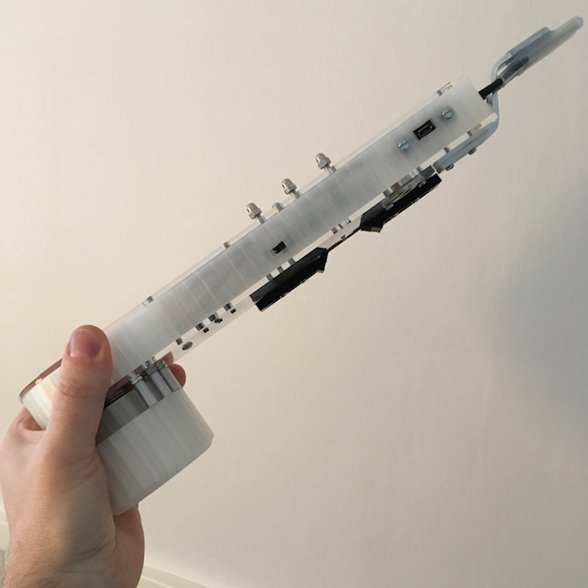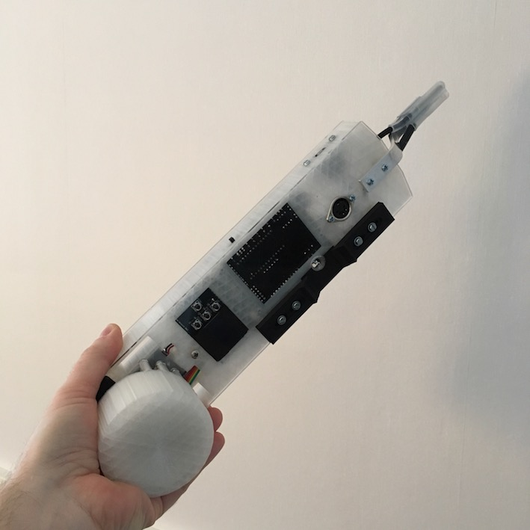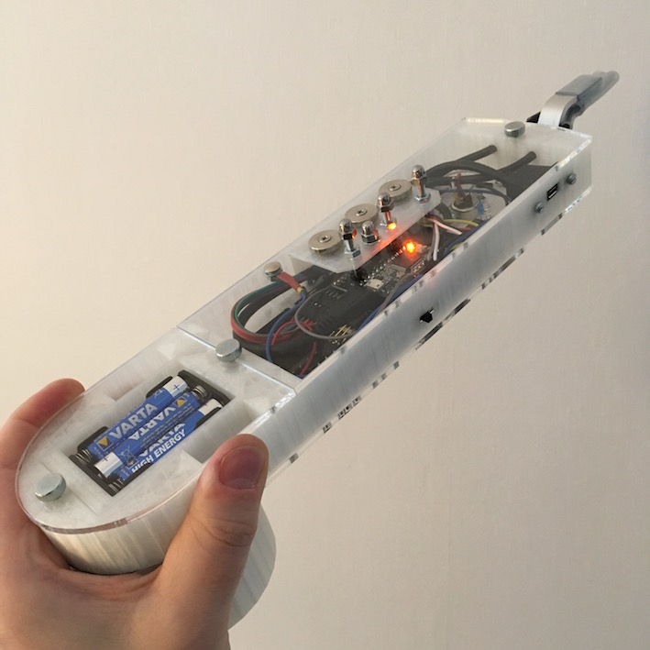
Controls

The mouthpiece has three sensors. The primary one is the breath pressure sensor. It controls note on/off and the continuos control value for breath sent to the synthesizer. The breath sensor system is of the closed kind. That means no air is flowing through the instrument when it is played. Instead you let air slip out by the sides of the mouthpiece when blowing into it. The second mouthpiece sensor is the bite sensor. This controls portamento (glide). A slight bite or bend to the mouthpiece will increase the glide time. When released, it goes back to zero/no glide. Third, there’s the extra controller sensor on top of the mouthpiece. This is a lip sensor that is touch sensitive and it can be set to control modulation, growl or sustain (hold).

The right hand has controls both on top of the instrument and on the bottom. Topside, there are three main valves (-2, -1 and -3 semitones), three trill keys (+2, +1 and +4 semitones), a ”special key” between two of the trill keys for chord and interval functions, and a 1/2 pitch bend key that will set pitch bend and vibrato values sent to 50% when held (can be configured to act as an adjustable trill key/transposition key instead). The keys are all activated by touch. On the bottom there are two touch sensitive pitch bend plates, behind and in front of the thumb. They are proportional and send pitch bend up and down in response to how much you let your thumb press against them. Between the pitch bend pads, there is a vibrato lever. This also sends pitch bend control to your synthesizer, but in a manner focused on vibrato. The lever senses position change. A forward movement triggers a slight pitch bend down followed by a return to zero when the movement stops. The movement back will then trigger a slight pitch bend up, followed by return to zero when movement stops. This creates a very violin like vibrato in a way that will feel natural to the player. A slight shaking hand motion back and forth with your thumb kept on the lever will produce this.

Left hand controls octaves and the fourth valve (perfect fifth, -5 semitones). Octaves are controlled using the thumb rollers. Let your thumb rest between two rollers. Rotate your hand while holding the canister and let your thumb move along the arc of rollers to change octaves. Octaves go from -3 (thumb left of leftmost roller, not touching it), to -2 (touching only the leftmost roller), -1 (between the first two rollers) and all the way up to +3 (between the two last rollers). Your index finger controls the fourth valve (-5 semitones), aka the side key. It is the arc in the front of the instrument, just above the canister.

Settings

To simplify configuration, the NuEVI has been equipped with an OLED display and four navigation buttons. The middle buttons are MENU/BACK (left) and ENTER (right), and the buttons above and below are the buttons for UP and DOWN selection. When not used for configuration or patch viewing, the display will be shut off to conserve power. Pressing MENU will activate the display and the main menu. A flashing cursor will indicate items, and ENTER will select the indicated item. Menu items directly controlling a setting will trigger a square being shown on the right in the display, with the adjustable value flashing inside it. Press UP and DOWN to select the desired value and then press ENTER or MENU to select that value and store it in non-volatile memory. The controller will remember this setting even if it is switched off. To make a temporary change that will not be stored, leave the menu open with the value flashing. After a while, the menu will shut off and the setting will not be stored.

TRANSPOSE

This menu item allows you to transpose the instrument up or down 12 semitones. Factory default transposition is C, +0 semitones.

OCTAVE

This menu item changes the octave transposition of the instrument. Values go from -3 to + 3, with +0 as factory default.

MIDI CH

This menu item selects the active MIDI channel, 1 through 16, for both DIN MIDI and USB MIDI. Factory default is MIDI channel 1.

ADJUST

Selecting this menu item enters the sensor adjustment screen. Here you can monitor sensor reading values and change the threshold and maximum (sensitivity) values for the sensors. Scroll through the various sensors using UP and DOWN buttons and press ENTER to move the cursor to THR and MAX items, where UP and DOWN buttons increase and decrease the values (the indicator bar for the setting is moved right or left). Note that the MAX setting can never be set lower than the THR setting. A moving pixel (SNS) indicates the current sensor reading. Where several sensors are involved, a pixel for each sensor will be shown. Also note that the intensive updating of the OLED display while using the SETUP menu will interfere with the transmission of MIDI CC data. For that reason, the ADJUST menu is to be used for setup only, not to be activated during normal play.

ADJUST - BREATH

THR level sets the amount of pressure needed to trigger a note and start sending breath MIDI data. The breath indicator LED will light up when pressure is over threshold. If the LED is always lit, even when you are not blowing into the mouthpiece, you need to raise the THR setting until the LED turns off.

MAX sets the pressure level that should correspond to full signal output. This setting is of course to your individual preference, and with different settings of the breath to signal transfer curve (SETUP BR - CURVE) you may want to adjust this too.

ADJUST - PORTAMENTO

THR level sets the amount of bite or bend action on the mouthpiece needed to start sending portamento control data. The portamento indicator LED will light up when bite input is over threshold. If the LED is always lit, even when you are not biting or bending the mouthpiece, you need to raise the THR setting until the LED turns off.

MAX sets the bite or bending level corresponding to full portamento signal output.

ADJUST - PITCH BEND

THR sets the threshold for the pitch bend touch pads. Make sure both of the SNS indicator dots are to the left of the THR line, or you will have issues with your pitch bend signal.

MAX sets the amount of finger pressure against pitch bend touch pads required for full signal output. When adjusting this setting, move your thumb up and down onto the pads to find a good setting. Note that what should be sent as full pitch bend signal is controlled in the SETUP CTR - PITCH BEND menu. The sensor MAX setting should always be set so the SNS reading is reaching the MAX line when the pads are fully touched.

ADJUST - EXTRA CTR

The extra controller, activated in the SETUP CTR menu, is the lip or embouchure sensor on top of the mouthpiece. It is a proportional touch controller, working much in the same fashion as the pitch bend pads.

THR sets the threshold for the lip touch sensor. Make sure the SNS indicator dot is to the left of the THR line when sensor is not touched.

MAX sets the lip touch corresponding to full controller signal output.

ADJUST - TOUCH

THR sets the threshold for the main keys (K1 through K7) and the octave rollers. When all keys and rollers are untouched, the SNS dots should all be to the right of the THR line. Keys touched one at a time, one of the dots should go left of the THR line. This both verifies connectivity and correctly set THR level.

SETUP BR

Submenu for settings related to breath control.

SETUP BR - BREATH CC

Sets the MIDI CC to be sent to represent the breath data.

OFF – No breath CC data is sent.
MW – Breath data is sent as CC#1 (Mod Wheel)
BR – Breath data is sent as CC#2 (Breath, factory default)
VL – Breath data is sent as CC#7 (Volume)
EX – Breath data is sent as CC#11 (Expression)
MW+ – High resolution breath data is sent on CC#1 and CC#33 (Hi-res Mod Wheel)*
BR+ – High resolution breath data is sent on CC#2 and CC#34 (Hi-res Breath)*
VL+ – High resolution breath data is sent on CC#7 and CC#39 (Hi-res Volume)*
EX+ – High resolution breath data is sent on CC#11 and CC#43 (Hi-res Expression)*
CF – Breath data is sent as CC#74 (Filter Cutoff)

*) High resolution MIDI is very often not supported in the receiving end, i.e. synths or DAWs. It also uses more MIDI bandwidth. In most cases you are better off with the regular CC signal. In cases where smoothing is not implemented in the receiving end, Hi-res CC can be a way to get less stepping in the filter control. As an example, the Minibrute gets stepping in the sound when the filter cutoff is controlled with Aftertouch, but a smooth sound when the filter is controlled by high resolution Modulation Wheel data.

SETUP BR - BREATH AT

Controls wether or not breath data should be sent as Aftertouch (Channel Pressure).

OFF - No Aftertouch breath data is sent (factory default)
ON - Breath data is sent as Aftertouch.

SETUP BR - VELOCITY

Note velocity can be set to follow the initial breath value dynamically (DYN) or to a fixed value (1 to 127).

SETUP BR - CURVE

This sets the breath sensor to control signal transfer curve. See curve diagram for a graphical representation of each curve.

-4 to -1 curves are more responsive (faster rising) in the low pressure end.
+1 to +4 curves are more responsive (faster rising) in the high pressure end.
LIN is a straight linear signal transfer.
S curves have a faster transition in the middle and is less responsive in the low and high pressure ends.
Z curves have a slower transition in the middle and is more responsive in the low and high pressure ends.

The LIN curve is factory default.

SETUP BR - VEL DELAY

The time it takes for a tongued note to reach its attack peak is generally about 20ms. Normally, that’s the amount of time the NuEVI waits until it samples the breath pressure level to set the note velocity. However, there are situations where we would want to adjust that delay. For example, if we are using a high THR value for the breath sensor, some of the rising time will occur before the THR is reached and the delay time starts. Also, if the connected synthesizer is not responding to velocity, setting the delay shorter will increase the response time. Even if the synth responds to velocity, you can experiment with cutting down the delay time and compensating for lower velocity values with the VEL BIAS setting.

OFF – No velocity sample delay.
5ms – Lowest delay setting
10ms
15ms
20ms (factory default)
..
30ms – Highest delay setting

SETUP BR - VEL BIAS

This setting helps boosting velocity values. Useful for compensating short velocity sample delays and for situations where you want to reach high velocity levels faster in relation to breath level.

OFF – Velocity bias disabled (factory default)
1 – Lowest setting
..
9 – Highest setting

SETUP CTR

Submenu for settings related to controllers in general.

SETUP CTR - PORT/GLIDE

Settings for the portamento/glide function (controlled by the bite sensor).

OFF – No portamento CC data is sent.
ON – Portamento Time (CC#5) is sent.
SW – Portamento Time (CC#5) and Portamento Switch (CC#65) is sent. (factory default)

SETUP CTR - PITCH BEND

The pitch bend signal can be divided to work with synthesizers that are not able to set the pitch bend range low enough to fit this kind of instrument. As an example, if a synth has a set pitch bend range of 12 semitones up and down, setting the pitch bend divider to 1/12 will limit the range to just a semitone up and down. The OFF setting will disable the pitch bend pads. Vibrato depth follows the pitch bend divider setting. If the pitch bend pads are disabled, the vibrato will still work at 1/1 range.

OFF – No pitch bend data is sent.
1/1 – Full pitch bend range. (factory default)
1/2 – Half pitch bend range.
..
1/12 - A twelfth of the pitch bend range.

SETUP CTR - EXTRA

The extra controller can be disabled or set to control transmission of selected MIDI CC data.

OFF – extra controller is disabled.
MW – Modulation Wheel (CC#1) data is sent. Disabled if breath data is sent over CC#1.
FP – Foot Pedal (CC#4) data is sent. Growl on some wind synth patches. (factory default)
CF – Filter Cutoff (CC#74) data is sent.
SP – Sustain pedal (CC#64). Holds fingered notes until controller is released.

SETUP CTR - VIBRATO

Menu for vibrato settings.

SETUP CTR - VIBRATO - DEPTH

This setting controls the vibrato depth.

OFF – Vibrato lever disabled.
1 – Lowest vibrato depth setting
..
9 – Highest vibrato depth setting

The factory default setting is 4.

Vibrato depth is also depending on the vibrato sensitivity setting. After fine tuning the sensitivity for a smooth vibrato response, you may want to revisit the depth setting.

SETUP CTR - VIBRATO - SENSE

This setting controls vibrato sensitivity. As individual vibrato sensors may vary in values a bit, this setting will help adjusting the sensitivity to get the best result.

Setting values go from 1 to 12, where 12 is the most sensitive.

SETUP CTR - VIBRATO - RETURN

This setting lets you adjust the speed of the automatic return to zero for the vibrato.

Values go from 0 to 4, where 4 is the fastest return and 0 is no automatic return, i.e. the vibrato lever will work as a conventional pitch stick. Normal EVI behaviour is auto return, and the default setting is 2.

SETUP CTR - VIBRATO - SQUELCH

This setting helps eliminate pitchbend MIDI chatter for when vibrato is not touched and idle. Setting it too high makes the vibrato lever require an unnecessary amount of movement before initiating vibrato, and with the setting too low the natural sensor noise will cause MIDI chatter around zero. To find the right setting, you may either use a MIDI monitor software on your computer or other device, or look at the orange LED on the Teensy in the NuEVI. When in this menu, the LED will turn off if the pitch bend signal is not zero. With the vibrato lever untouched, it should glow steady or just very rarely blink off. If you touch the lever just slightly, the LED should turn off briefly, then go back to a steady on. When you are pleased with the setting, press ENTER or MENU to save it.

Setting values go from 1 to 30, where 15 is the factory default.

SETUP CTR - VIBRATO - DIRECTION

This setting lets you set the direction of the vibrato. For most people this should be kept to the default setting NRM (normal), where the pitch will fall in response to thumb movement in direction away from the mouthpiece.

SETUP CTR - DEGLITCH

To reduce glitching when fingerings are changed, the deglitching function waits some milliseconds before considering a fingering “done” and settled. Beginners will probably feel the need to increase the deglitch setting, while virtuoso players could feel the need to reduce the setting.

OFF – Deglitching disabled
5 ms – Lowest deglitch setting
10 ms
15 ms
20 ms (factory default)
..
70 ms – Highest deglitch setting

SETUP CTR – PINKY KEY

The standard and legacy behaviour of the pinky key is to set the pitch bend signal to half its value while the key is pressed. In the NuEVI, we have added the possibility to instead use the pinky key for instant transposition, or an adjustable trill key if you like.

- 12 – transpose one octave down when pinky key is held
..
- 1 – transpose one semitone down when pinky key is held
PBD – Pitch Bend Divide, PB and vibrato level is half value when pinky key is held
+1 – transpose one semitone up when pinky key is held
..
+ 12 – transpose one octave up when pinky key is held

PBD is factory default.

Patch selection

Pressing the ENTER button when the display is off will show the currently selected patch number on the display for a couple of seconds. Pressing UP or DOWN changes the patch number. You can hold the button pressed to get a faster scrolling through the numbers. Pressing the UP or DOWN button when the display is switched off will directly enter the patch view mode and step the patch number up or down.

The patch number will be remembered by the controller even when powered off. Holding ENTER button while powering up the NuEVI will have it send a program change for the current patch selected.

FastPatch selection

You can store up to seven patch numbers that can be instantly recalled by holding a combination of trill keys when pressing any of the buttons ENTER, UP or DOWN from display sleep or patch view state. (Just reach with your LH thumb without looking.) If no patch number is stored for the selected memory slot, the selection will be ignored, and the current patch number will be displayed.

To save a patch number into a memory slot, use UP and DOWN to select the patch you want to store (no trill keys touched). From display sleep, finger the trill key combination you want to use as memory slot, press and hold MENU, then immediatly press ENTER while still holding MENU. The display will briefly indicate that the FastPatch has been set.

To clear a FastPatch memory slot, finger the trill key combination for the slot, press and hold MENU, then immediatly press UP while still holding MENU. The display will briefly indicate that the FastPatch slot has been cleared.

Mind that accidentally touching trill keys when using UP, DOWN or ENTER for patch selection will recall a FastPatch or just display the current patch if no FastPatch is set for that slot, so keep fingers off the trills if you are just doing regular patch selection.

All notes off

Should a situation of stuck notes occur, a ”midi panic” or “all notes off” can be sent by pressing and holding the ENTER button, then the MENU button while still holding ENTER, from display off state. Big friendly letters on the display will also tell you not to panic.

Special key

Introduced with the Steiner MIDI EVI, the special key added the possibility to play chords and intervals. This has been implemented in the NuEVI too.

The first function is slur sustain. To activate this, touch the Special key while holding a finger on K4 (side key or arc key). Slur sustain will send a sustain (hold) pedal on command when a new note is tongued, keep it held as long as new notes are slurred, building chords by slurring and holding them until breath is released. A new chord can then be started by tongueing a new note. The latest chord or interval played will be stored for use with the parallel chord or interval function.

Parallel chord or interval is activated by touching the Special key while holding K5 (first trill key). If no chord or interval has been stored by slur sustain, a default interval of a perfect fifth below the played note is used.

Activating slur sustain will switch the parallel chord function off and any intervals or chords slurred will then overwrite the previously stored chord.

The sub octave double function is activated by touching the Special key while holding K1 (first valve). This adds a note played one octave down from played note(s). This can be used in combination with slur sustain or parallel chord functions.

Touching only the special key will switch off any active special key functions.

Rotator

As an additional chord playing feature, we have added a ”rotator” that will bring some extra magic into the chord playing. It creates a three note chord using your base note, a fixed interval parallel note and a third note taken from a rotating selection of four notes. For every new note triggered, the rotation is advanced one step, and a new combination of notes is played.

To activate the rotator, touch the special key while holding the pinky key. This will at the same time switch off any other special key functions.

Setup of the rotator note intervals can be done in a special menu that you acceess by pressing the MENU button while holding the pinky key. PARALLEL sets the fixed parallel note and ROTATE 1 – 4 sets each of the four intervals being rotated for the third note. PRIORITY sets which note will get priority when playing mono patches (sounds really great to layer a mono patch with a poly patch for use with rotator/chord play). MEL will play the base note as the mono lead and ROT will play the rotated note. This setting also affects playing with parallel chord and interval, where you can choose from having the base note or the last note of the chord as the lead voice.
Legacy instant controls

The MIDI EVI was using fingering combinations to alter settings and send patch change commands. For advanced users this can still be a desired thing, so there’s support in the NuEVI for the most important parts.

To toggle this functionality on and off (default off), touch the extra controller lip sensor with your lip, then use your LH thumb to press the menu button. (It is intentionally a bit tricky.) The LED on the Teensy will flash twice to indicate successful switching.

When the legacy instant controls are activated, you can instantly recall a patch number by its respective MIDI note number. For example, by fingering middle C (any transpositions set are not active here) while not playing, you are selecting patch number 72. Touch both pitch bend pads at the same time to send the patch change command for the patch number you are fingering. The Teensy LED will flash once to confirm. Note that if that patch number is already the patch known as active in the NuEVI, the command will not be sent. To select patch numbers in the top and bottom end of the range 1 to 127, add the pinky key to your fingering.

Using MIDI channel switching can be useful for switching between synths or patches in performances. To instantly select a MIDI channel number, you can finger it using middle C and upwards cromatically, where mid C represents MIDI channel #1, touch the lip sensor with your lip, then touch both pitch bend pads at the same time. The Teensy LED will flash once to confirm. Note that a MIDI setting selected this way will not be remembered after powering off, unless you go into the MIDI CH menu to confirm the change. This way, if you have no idea why you suddenly can’t get a sound (because you accidentally managed to switch to some other MIDI channel) a power cycle will get you back in business.

Another way to trig the instant controls is to apply a gentle sucking (negative air pressure) to the mouthpiece instead of touching both PB pads. To toggle this functionality on and off (independently of PB pads trig functionality), hold extra controller (lip) and the pinky key when pressing the MENU button.

Using the sucking together with pitch bend down, Nyle has added the legacy program button control to the NuEVI. For notes on that, see last page.

Gate Hold

A trick for getting smooth attacks on some synths, where you don’t need velocity values, is to keep notes always on and control the volume/filter with breath only. A way to do this is to change the breath THR value to be just slightly below the idle reading. This is a bit unpractical though, so we put in a little bonus thing to make it easier.

To activate Gate Hold, grab the canister like a door knob, touching the side key and the bottom three rollers at the same time. Then touch the pitch bend up pad. The Teensy LED will flicker to indicate activation.

To deactivate Gate Hold, do the same thing but with touching the pitch bend down pad. The LED will flicker three times to confirm.

While Gate Hold is on, some setting changes (like MIDI channel or patch number) will not take effect until Gate Hold is switched off again.

Connections

The NuEVI has two ways of connecting to synthesizers and computers. The first is using the standard DIN MIDI OUT jack, connecting using a standard MIDI cable to the MIDI IN of a hardware synth or computer MIDI interface. The second way, new to the EVI world, is by using the Micro USB port on the side of the NuEVI. Using a standard Micro USB charge/sync cable, you can connect the controller to any computer or MIDI USB host hardware supporting class compliant MIDI over USB. The NuEVI will be recognized as ”NuEVI MIDI” by your system. Using a Lightning to USB Camera Adapter, you can even connect your NuEVI directly to an iPad or iPhone and use it with softsynth apps.

The Micro USB connection will also power the NuEVI when the battery switch is in the backmost position (battery power off). The low power requirement of the NuEVI makes it possible to run it from any computer USB port, USB charger (please use quality ones and don’t put your instrument at risk) or even from your iPad. Mind that switching between USB power and battery power will switch the controller off and on again.

Pitch bend pad adjustment

The pitch bend pads can be loosened using a screwdriver and slightly shifted in distance from the thumb rest. Find the placement that makes most sense to you and tighten the screws. Don’t over-tighten, as you could cause damage to the conductive plastic of the pitch bend pads if you do. If the pad is not moving or wiggling when pressed against from the thumb rest position, you should be good to go.

Battery check

When the main menu is activated, the battery condition will be indicated top right of the display. Values over 4.8V will indicate that the instrument is powered over USB, and below that it will indicate it as battery voltage. Normal voltage for a set of new alkaline batteries will be about 4.6V. The value will drop as the batteries are being used, giving a hint of the current battery condition. Below 3.7V they are due to be replaced, and the indicator will say BAT LOW.

Battery replacement

With the NuEVI switched off and disconnected from USB or DIN MIDI, unscrew the frontmost thumbscrew on top of the controller and loosen the one at the back of the battery compartment slightly. Slide the lid forward and lift it off the controller. Replace the batteries (3xAAA 1.5V alkaline) and slide the lid back in place. Get the front thumbscrew in place first, then tighten both screws. Only finger gripping power should be applied. Do not use pliers or similar tools or you will most certainly scratch the plastics of your instrument.

Firmware updates

Updates for the NuEVI firmware are supplied in .hex format when new features or bug fixes are released. The current firmware version is shown in the NuEVI display while powering on. Firmware upload is done using a software tool called Teensy Loader. It can be downloaded from https://www.pjrc.com/teensy/loader.html, where you also find instructions for using the Teensy Loader to upload the .hex file. To restart the NuEVI in program mode, making it visible to the Teensy software, press all four buttons by the NuEVI display simultaneously while the display is not active (or open the case slightly and press the program button on the Teensy). If you get a message in the Teensy loader app that the hex file you selected is too big, just ignore it and put your EVI in program mode. The board version will be recognized and the hex file can be uploaded. If the app is in Auto mode it will upload as soon as you get the EVI in program mode, otherwise you need to click Program and Reboot after the Teensy chip has been recognized and the Teensy picture in the app has gone from faded to normal.

Mind that major updates to the firmware will often reset the NuEVI to default settings, including sensor adjustments (updating 1.0.5 or higher will keep the sensor adjustments). You will be required to set it up again to your liking after the update. Please take notes (or pictures) of your custom settings if you are unsure.

Factory restore

To restore the factory default settings, including sensor adjustments, hold ENTER and MENU buttons when switching on the NuEVI. Release when the orange LED glows steadily.

Fingering chart

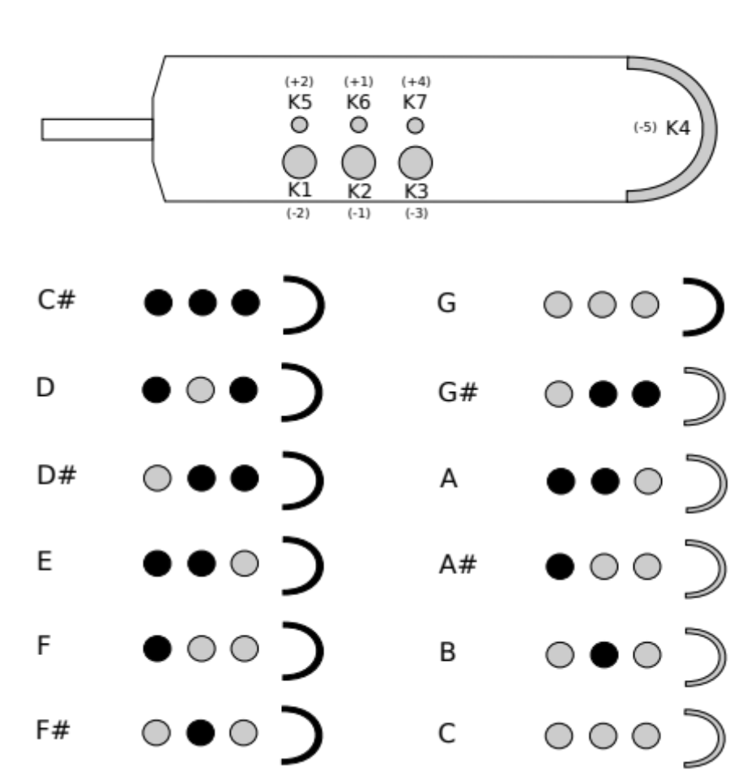

These are just the core fingerings. Experiment with the trill keys (K5 to K7) to find useful alternate fingerings near octave breaks and in other situations where they could come in handy.
Nyle’s program button notes

I have added the equivalent of the vintage midi evi programming button.
It is activated by holding the down pitch bend and sucking.
The legacy breath activate feature must be toggled on for this to work. Press MENU button while holding extra controller and pinky key as per instruction manual.

Implemented so far:
1. Middle octave position (c72). Ability to assign midi breath parameters, midi volume, midi aftertouch, midi breath, midi expression and velocity.
1v - midi volume
2v - midi aftertouch
3v - midi breath controller
side button - midi expression
1tr - note on velocity

2. Lowest octave position (c36). Ability to increment - decrement and send midi patch change commands.
F29 - decrement and send patch change
G31 - increment and send patch change

E28 - subtract 10 and send patch change
F#30 - add 10 and send patch change
When NuEVI is turned on, Incr - Decr starts from whatever patch number is stored in EEPROM.

3v - send reverb amount cc91, value determined by pinky pitch latch. C36 equals zero. Vintage evi never had this reverb send feature; I put it in here just because my own setup takes advantage of it.

I still want to add a C36 (open with no keys) All Notes OFF command but have not done it yet.

Pinky pitch latch works exactly the same as it does on the vintage midi evi. When not blowing, just press pinky key momentarily while holding a note fingering. The note and octave position will determine a value and store it in ram memory (latch). This value can then be assigned to a parameter using the programming button.

Note: Calling patch changes randomly by fingering is not part of this programming button feature and does not use the pitch latch. You simply suck with no pitch bend applied and a patch is sent according to which note you are holding. This simulates the missing patch change button that is also on the vintage midi EVI.

Nyle

